FRONT END – PART 1
MORE ON HTML

(DIV Element)
1. The element <DIV> has which of the following property
a) provides some properties to elements inside it b) define content to be block-level
c) define content to be inline d) none of the above

(Correct Code Structure)
2. Which of the following code structure will produce the output as shown in figure(height of both pictures is 100px):
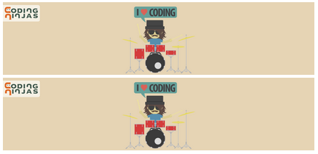

a) <p><img><img></p> b) <div><img></div><img>
c) <img><img> d) both a. and b.
SOLUTION DESCRIPTION:
tag is a block-level tag due to which the image will automatically be displayed in the next line otherwise it may appear in the same line. So,
is the correct option.

(Sematic Meaning)
3. A semantic element clearly describes its meaning to
a) Browser b) Developer
c) Both A & B d) None of them

(Semantic Tag)
4. The semantic markup tag -
a) provides extra information b) provides meaning to the content on web page
c) both a) and b) d) none of the above

(Not Semantic Element)
5. Which of the following is not a semantic element?
a) <form> b) <article>
c) <table> d) <span>

(Element for Sidebar)
6. Which element works as a sidebar?
a) header b) footer
c) nav d) aside

(Section Element)
7. Consider the following statements regarding the section element

1. It is a semantic element as it clearly
describes its meaning to both, the browser
and the developer.
2. The content of a semantic element shares
a single theme.
3. It is a non-semantic element as it gives
no information about its content.
4. It is a non-semantic element as it is a
generic block element used to wrap related
content.

Select the correct statement:
a) Only 1 is correct. b) Both 1 and 2 are correct.
c) Only 3 is correct. d) Both 3 and 4 are correct.
SOLUTION DESCRIPTION:
Explanation: Section tag is a semantic tag as it clearly describes its meaning to the browser and the developer. Although it is a generic block element, it is used to wrap related content.

(Not Block Element)
8. Which of the following is not a block element?
a) <h1> b) <ul>
c) <p> d) <a>

(Code Shown as)
9. How will the elements in the given code be shown:

<img src=”img.jpg” width=”100” /><a href=””>This is image</>

a) Link will be displayed above the image b) Link will be displayed next to the image
c) Link will be displayed below the image d) Link will be displayed before the image

(Similar to B Tag)
10. Which element works similar to <b> element?
a) <fat> b) <strong>
c) <black> d) <emp>
SOLUTION DESCRIPTION:
Explanation: The <b> element works similar to the <strong> element in appearance. But <strong> is used over <b> when we wish to emphasize the importance of the text being made bold.

(Italic Text)
11. Correct HTML tag to make a text italic?
a) <italic> b) <it>
c) <i> d) any of the above

(Span Element)
12. Which statements is/are true for span element (multiple answers correct)?
a) It is used as an inline container for grouping elements to style them.
b) It is used as a block-level container for grouping elements.
c) It can be used for text formatting or to style specific words in a sentence.
d) It is a non-semantic element.
SOLUTION DESCRIPTION:
Explanation: Span element is an inline element. It can group elements together for
styling purposes. It is a non-semantic tag with no defined semantics for the content that it encloses. You can use span tag for text formatting.

(& Symbol)
13. Which entity will generate ‘&’ symbol?

Hint: Refer to the extra link provided in the
notes given above to get a list of special
characters along with their codes.

a) &and; b) &amp;
c) &ann; d) none of the above

(Space Entity)
14. What entity can provide multiple spaces between texts?
a) &nbsp; b) &ensp;
c) &emsp; d) all of the above
SOLUTION DESCRIPTION:
All of them are used to provide spaces but of different numbers.
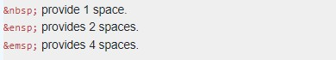

(Currency Symbol)
15. Can you add currency symbols using the HTML entities?
a) Yes b) No

(Special Syntax)
16. Why do we need to represent certain special characters in a specific syntax to print them in the browser?
a) Because not all characters can be printed using a keyboard.
b) Because HTML doesn’t support printing certain characters directly.
c) Because the meaning of certain characters is reserved in HTML.
d) All of the above.
SOLUTION DESCRIPTION:
You need to represent certain special characters in a specific syntax to print them in the browser since all characters can not be printed using a keyboard, also there are certain characters that HTML doesn’t support printing directly, and the meaning of certain characters is reserved in HTML.

(Table Tags)
17. The main container for <tr>, <td> and <th> is -
a) <data> b) <group>
c) <table> d) none of the above

(Table Load)
18. When is the content of a table shown?
a) Before the border loads b) After the table is loaded
c) In pieces as it loads d) None of the above

(Row Tag)
19. Which tag allows you to add a row in a table?
a) td b) rw
c) tr d) th

(Table Border)
20. Does the table contains border by default?
a) Yes b) No

(TD Tag Use)
21. What will be added by using <td></td> tag ?
a) cell b) row
c) step d) column

(Merge Cells)
22. Which attribute you’ll use with TD tag to merge two cells horizontally?
a) merge=colspan2 b) rowspan=2
c) colspan=2 d) merge=row2

(Cell Padding)
23. Increasing the cell padding means -
a) Increase the softness of your site b) increase the space between cells
c) increase the distance between cell and content d) all of the above

ASSIGNMENT

(Visible Heading)
24. Which of the following defines a visible heading for <details> element?
a) summary b) section
c) mark d) main
SOLUTION DESCRIPTION:
Summary tag is acts as a caption for the details tag and can be clicked to toggle the state of the parent
Details
element open and closed.

(Additional Details)
25. Which element defines additional details?
a) <summary> b) <main>
c) <aside> d) <details>

(Computer Code)
26. Which element denotes that the text is a short fragment of computer code?
a) <data> b) <code>
c) <cite> d) <dfn>

(Increase Font Size)
27. How to increase the font size of the displayed text in HTML 5?
a) By using large tag in html. <large></large> b) By setting higher font size in css style.
c) By using size tag in html <size></size> d) By using big tag in html <big></big>

(Small and Big Tag)
28. The <small> and <big> tags are special in a what way?
a) They are for images only b) They work on anything
c) They can be repeated d) None of the above
SOLUTION DESCRIPTION:
Small and big tags can be repeatedly applied to a text to make it smaller or bigger to the extent we want.

(Code Appears in Browser)
29. How will the code below would look like in the browser:

<article>
<p>1. This is a <b>para</b></p>
<a>2. This is a link.</a>
<a>3. This a link</a>
</article>
<br/>
<strong>Guess the above structure.</strong>

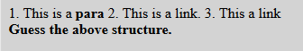
i.

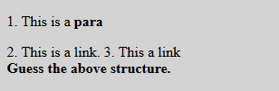
ii.

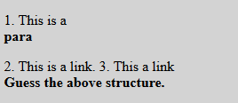
iii.

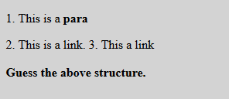
iv.

a) i b) ii
c) iii d) iv

(Image Inside Table)
30. Can a data cell contain images?
a) Yes b) No

(Table In Table)
31. Is it possible to insert a table within another table?
a) Yes, but there must be exactly 2 rows and 2 columns in first table.
b) Yes, table can be inserted into cell of another table.
c) Yes, but there must be no border in other table.
d) No, it’s not possible.

(H1 Tag)
32. Choose the correct statement for <h1> tag?
a) <h1> tag is a semantic tag. b) <h1> tag is a non-semantic tag.
c) <h1> tag can’t be categorized into semantic or non-semantic tag.
SOLUTION DESCRIPTION:
h1 tag encloses content with clear semantics i.e. it represents a heading. Hence it's a semantic tag.

(Find the Output)
33. Determine the output for the following code:

<div>
<a href="https://codingninjas.com/">Coding
Ninjas</a>
</div>
<div>
<a href="https://Google.com/">Google</a>
</div>
<hr>
<span>
<a href="https://codingninjas.com/">Coding
Ninjas</a>
</span>
<span>
<a href="https://Google.com/">Google</a>
</span>

Hint: Figure out which elements are block or inline.

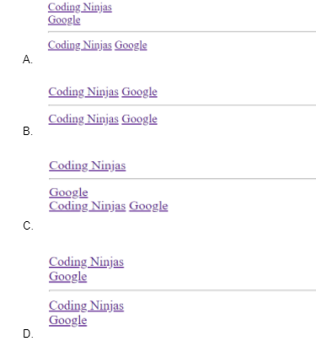

a) A b) B
c) C d) D
SOLUTION DESCRIPTION:
Correct answer is option A since the div element is a block-level element while the span is an inline element Also anchor element is an inline element.

(HTML Table)
34. Which of the following is/are true regarding HTML tables? (multiple options correct).

Hint: Code and experiment to answer this.

a) <table> is a semantic tag.
b) It doesn’t matter if the tr, td elements are wrapped in the table element or not. The output in the browser will be the same for both.
c) The tr, td elements have no significance of their own (as a table row or table data) until we wrap them in the table tag.
d) The table is a block element.
SOLUTION DESCRIPTION:
The browser considers content inside tr,td elements to be plain text if they are not enclosed within the table tag. Also, not using the table tag will not result in the formation of a table in the browser, hence it’s important.
The table takes up 100% width of the screen blocking elements from the right and left.

**********

